

# DIGITAL LOGIC DESIGN

**CS-154**

**COURSE PROJECT-SPRING-2020**

**PROJECT TITLE HERE!**

**SUBMITTED BY**

|  |  |  |
| --- | --- | --- |
| **Roll No.** | **Student Names** | **Section** |
| 19011519-062 | Zain Asghar | B |
| 19011519-115 | Muhammad Bilal | B |
| 19011519-129 | Sabir Hussain | B |

**INSTRUCTOR**

**MR. TOQEER EHSAN**

**DEPARTMENT OF COMPUTERSCIENCE UNIVERSITY OF GUJRAT**

**INTRODUCTION**

This Project is a Digital Thermometer. It is a digital thermometer that uses an Arduino Board, a breadboard, a Potentiometer, a display and some wires, it senses the temperature through the sensor, then after processing this temperature from Celsius to Fahrenheit and Displays it in the display screen.

This project is a good practical application of the course Digital Logic Design (DLD). It provides us with understanding of the different components like Arduino board and sensors including in this project. It opens a gate for a way to creativity, as well as, it plays an important role in our better understanding of our course.

**APPLICATIONS AND BENEFITS OF DIGITAL THERMOMETER :**

**Medical Applications**: The digital thermometers are used to measure human body temperature around 37⁰C. These thermometers are mostly probe type or ear type. It measures oral, rectal, and armpit body temperature.

**Marine Applications**: Digital thermometers with a high-temperature exhaust gas sensor as the temperature sensor can be used in marine applications for measuring the local temperature.

**Industrial Applications**: Digital thermometers are also used in power plants, nuclear power plants, blast furnaces, shipbuilding industries, etc. They can measure temperature from -220⁰C to +850⁰C.

**EQUIPMENT**

The equipment we used in our project to make a Digital Thermometer are given as follows :

* Arduino developed board
* Temperature sensor
* Potentiometer
* LCD
* Breadboard
* Wires

Now there is a little detail and usage of each component used in the project which is given bellow:

### Arduino Board:

The Arduino is open-source, which means hardware is reasonably priced and development software is free. It has gained considerable traction in the hobby and professional market

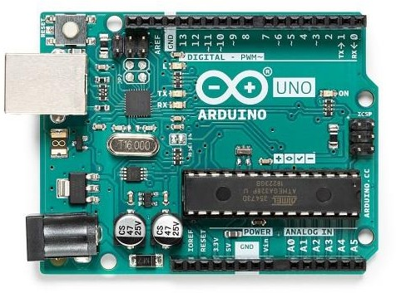

### LM 35 Temperature Sensor:

LM 35 are used to sense the heat around it. LM 35 digital

sensor has got 3pin’s i.e., VCC, GND and output pin’s when LM 35 is heated the voltage at output pin increases. It is connected to the analog to digital convertor IC (ADC).

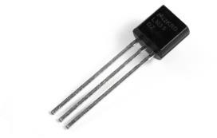

### Liquid Crystal Display (LCD):

Most common LCDs connected to the microcontrollers are 16x2 and 20x2 displays. This means 16 characters per line by 2 lines and 20 characters per line by 2 lines, respectively. It has a controller chip which receives data from an external source and directly displays it on screen.

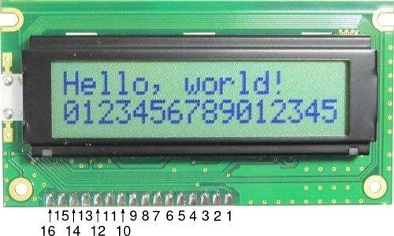

**DESIGN**

The Schematic Diagram of Digital Thermometer:

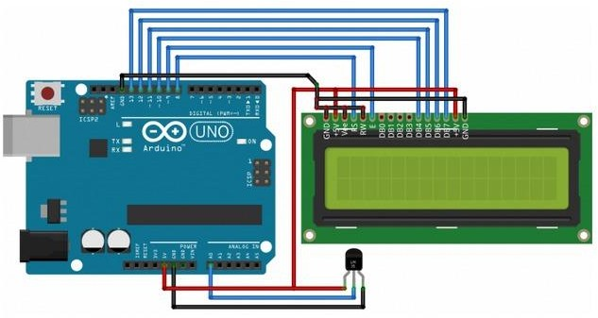

The Circuit Diagram of Digital Thermometer:

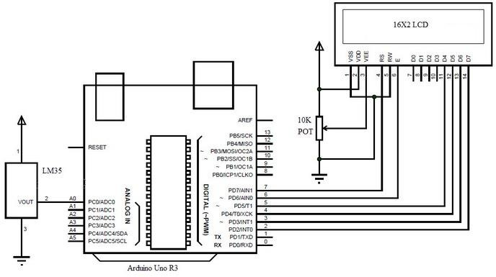

**WORKING OF DIGITAL THERMOMETER:**

The heart of the circuit is an Arduino board which controls all its functions. An IC LM35 is used as temperature sensor and RTC ds-1307 is used as a time sensor. The LM-35analog temperature and RTC 1307 device is interfaced to the analog pin of the Arduino board. It’s built-in ADC, which converts these analog reading and displays that on the LCD, to indicate temperature and time of the surroundings. Time and temperature can be displayed in any sequence as desired by doing changes in program uploaded on Arduino. RTC also help in displaying day of week.

## RESULTS/OUTPUTS.

The working model of Digital Thermometer is given below:

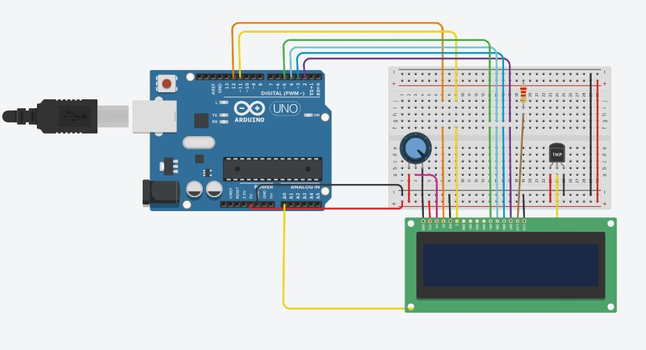

As we can see from above design, the power to the Arduino is off, so there is no output n the screen.

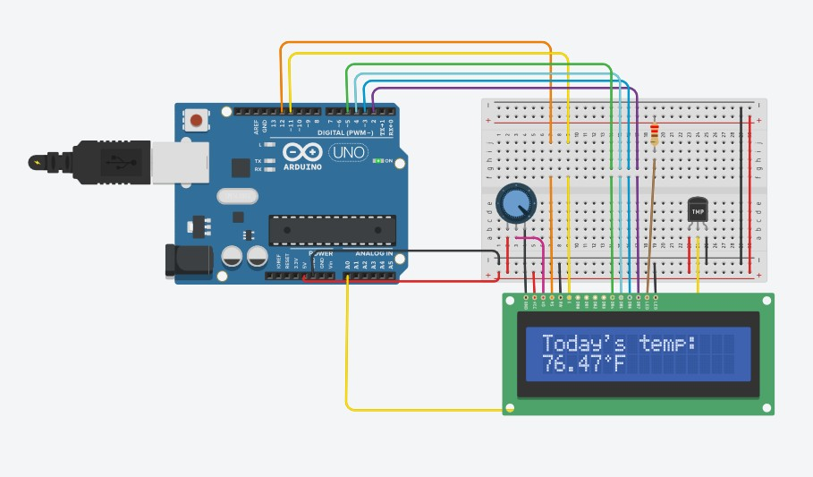

As we can see from above design, power input is given to the Arduino board, so the temperature sensor senses the temperature, the aurduino board takes the input and processes it and converts it into Fahrenhiet and displays the temperature on the output screen.

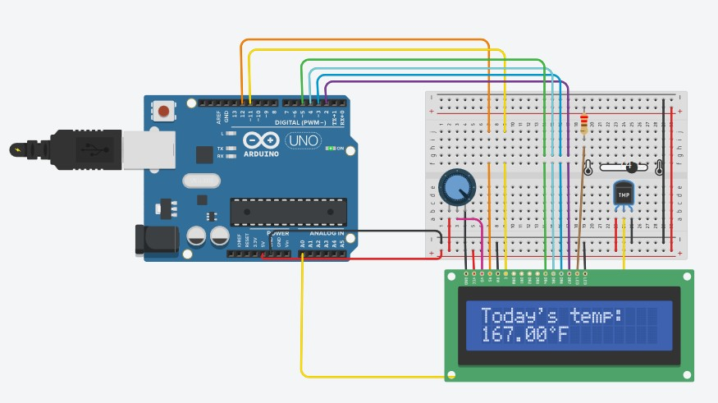

In the above image, we can see that the temperature on the temperature sensor has been changed, so that the output on the display screen has been changed too. The output on the display screen varies as the temperature on the temperature is changed.

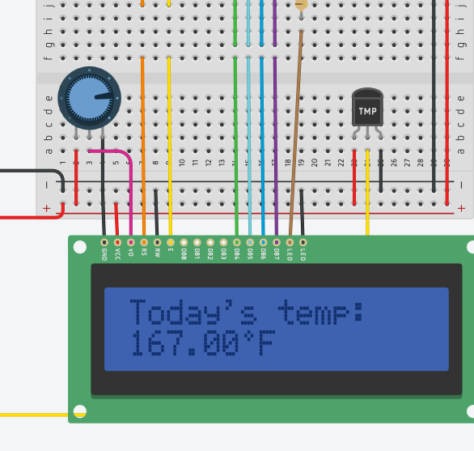

In the above Image, by changing the point on the potentiometer, the contrast/visibility is changed on the display screen.

## SUMMARY

Basically our main purpose to design this thermometer was to facilitate our community to calculate the temperature. The main benefit of this thermometer is that it is the most accurate and afficient tool to calculate the temperature. In addition to all above it also has a major advantage that is can also convert the temperature in celcius into Fahrenheit. As in most of the circumstances people use to prefer the temperature in Fahrenheit so we came up by the addition of this facility of temperature also.Plus in this thermometer by the variation the celcius temperature the temperature in fahrenheit will also be changed.